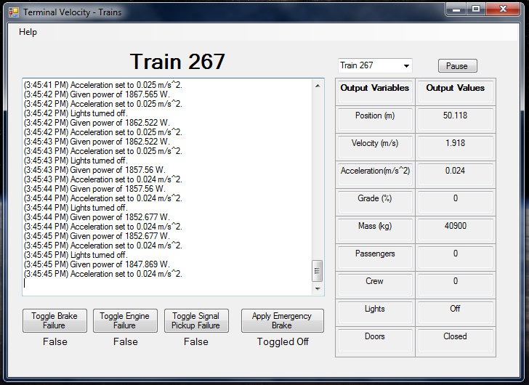

9

8

7

6

5

4

1

3

2

1. This label displays the current train being viewed.
2. This text box displays the last 2000 pieces of information for the train.
3. This combo box allows the user to change the train being viewed. It contains every train that is currently on the track.
4. This button stops the GUI from updating. By pressing it a second time, the GUI will start updating again.
5. This table displays all important information about the currently selected train.
   1. Position – current position of the selected train along the current track block in meters
   2. Velocity – current speed of the selected train in meters per second
   3. Acceleration – current acceleration of the selected train in meters per second squared
   4. Grade – current grade percentage of the track block the selected train is on
   5. Mass – current mass of the selected train in kilograms
   6. Passengers – current number of passengers on the selected train
   7. Crew – current number of crew members on the selected train
   8. Lights – the light status of the selected train
   9. Doors – the door status of the selected train
6. By pressing this button, the user can toggle a brake failure for the currently selected train.
   1. The status of the failure is displayed below the button.
      1. False = no failure.
      2. True = failure.
7. By pressing this button, the user can toggle an engine failure for the currently selected train.
   1. The status of the failure is displayed below the button.
      1. False = no failure.
      2. True = failure.
8. By pressing this button, the user can toggle a signal pickup failure for the currently selected train.
   1. The status of the failure is displayed below the button.
      1. False = no failure.
      2. True = failure.
9. By pressing this button, the user can toggle the emergency brake for the currently selected train.
   1. The status of the emergency brake is displayed below the button.
      1. Toggled Off = emergency brake is not pulled.
      2. Toggled On = emergency brake is pulled.